Two Dimensional Arrays
________________________________________________________________________________
Two dimensional array is used for create the matrix but it is not a matrix internally it is sequential memory management of array

How to declare two dimensional arrays
_____________________________________________________________________________
Syntax:
datatype variablename[][];
or
datatype [][]variablename;
or
datatype []variablename[];
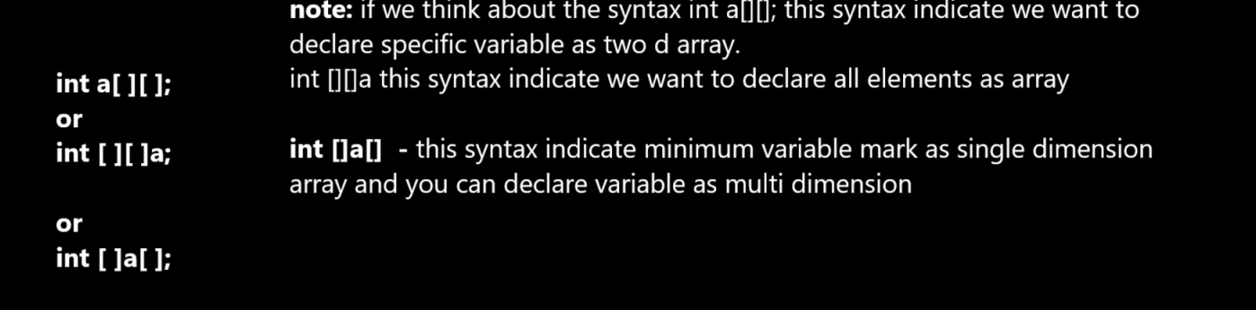

How two dimensional array stores in memory
_____________________________________________________________________________________
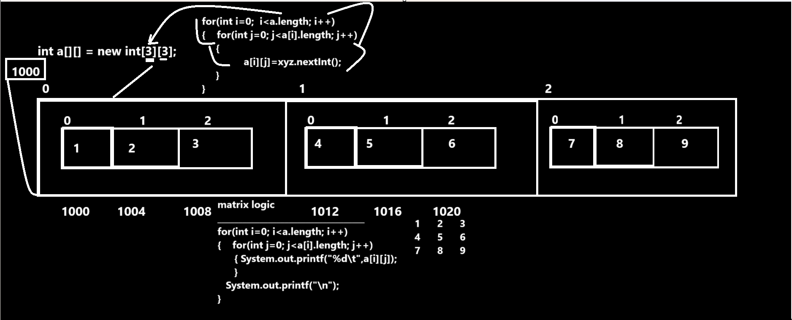
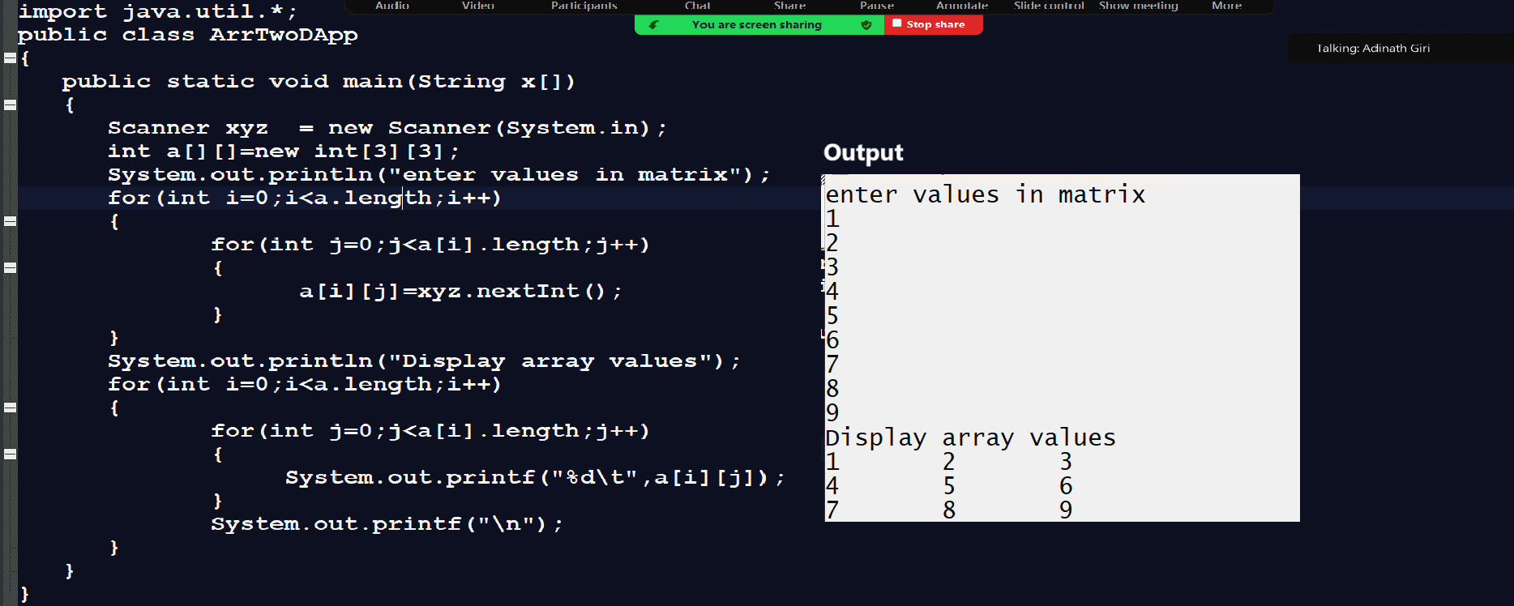

Jagged Array in JAVA
_________________________________________________________________________
Jagged Array is facility in Java where we can create matrix every row having a different column list
Means we can say jagged array is basically two dimensional arrays.
Syntax:
datatype variablename[][]=new datatype[rowsize][];
variablename[rowindex]=new datatype[colsize];
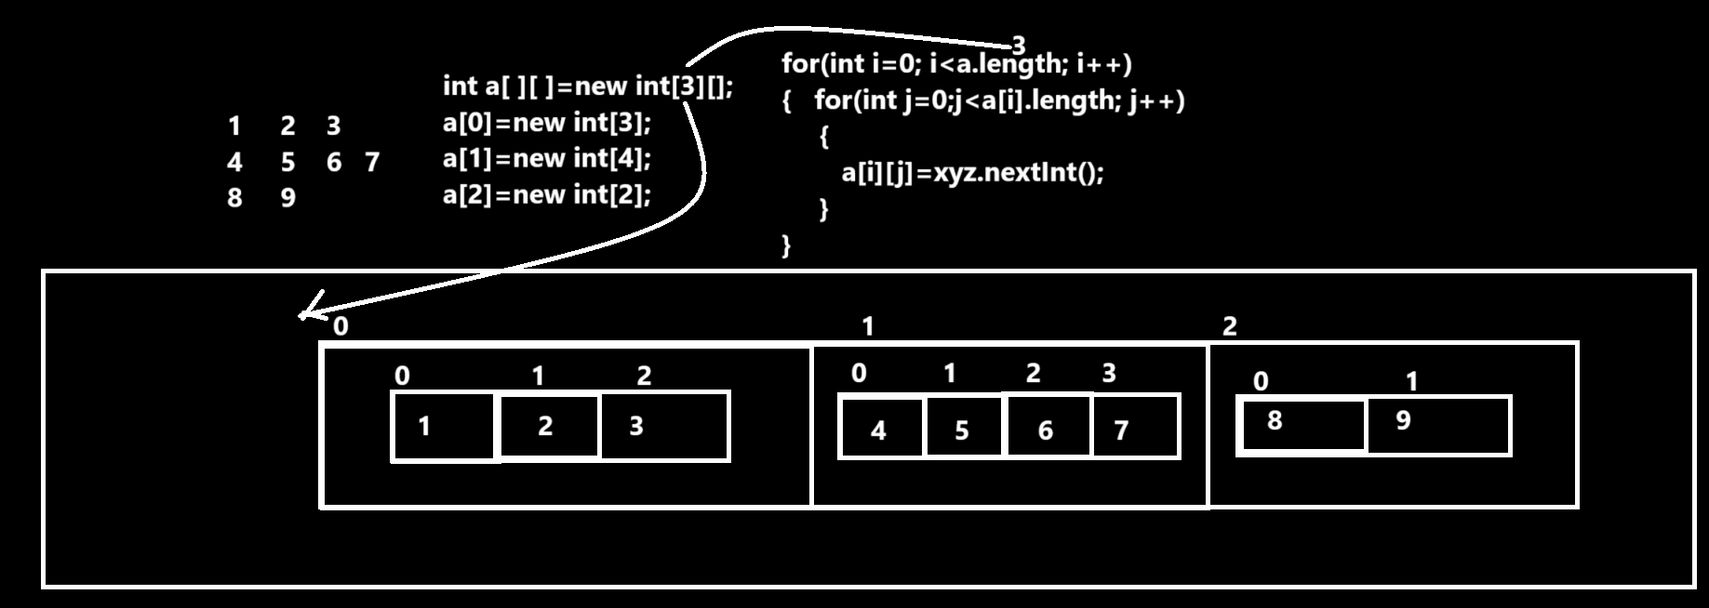
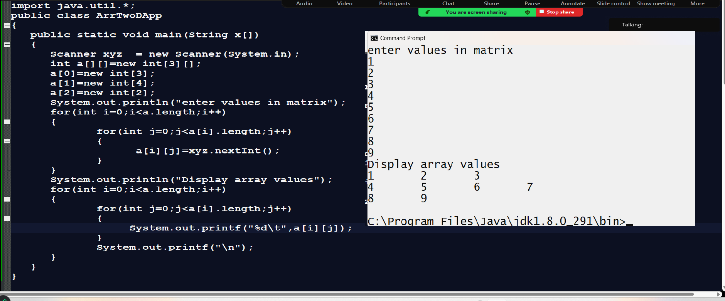
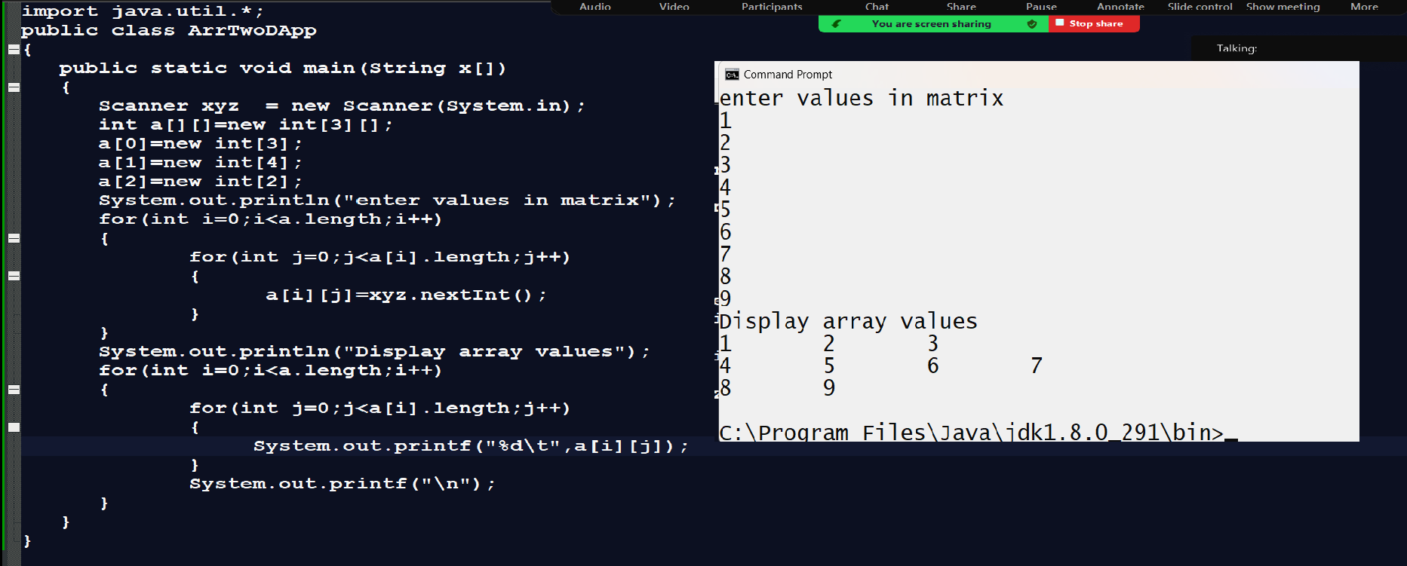

How to initialize the two dimensional array
____________________________________________________________________________________
Some we need to give the fixed data to array at the time of declaration so when we provide data to array at the time of declaration called as initialization.
